TP7 SGBD

4) CREATE TABLE Telephone (

numero integer primary key,

prix_forfait money

);

5) CREATE TABLE Contact (

num counter,

nom text(50)

);

6) DROP TABLE Telephone ;

7) ) CREATE TABLE Telephone (

numero integer primary key,

prix_forfait money

);

8) ALTER TABLE Contact

ADD CONSTRAINT primary_Contact PRIMARY KEY(num) ;

9) ALTER TABLE Contact

ADD birthday DATE;

10) ALTER TABLE Telephone

ADD numPers integer;

11) ALTER TABLE Telephone

ADD CONSTRAINT foreign_Telephone FOREIGN KEY(numPers) REFERENCES Contact(num);

12) ALTER TABLE Telephone

DROP prix_forfait;

13)

INSERT INTO Contact VALUES ("Secrétariat Info, Nice",#02 10 1973#);

INSERT INTO Telephone VALUES (0497258307,2)

INSERT INTO Contact (nom) VALUES ("Secrétariat Info, Sophia");

INSERT INTO Telephone VALUES (0497155210,3)

14) 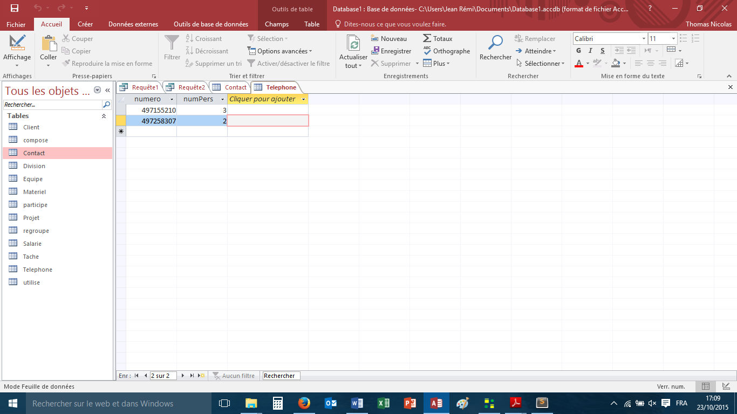

Le 0 a sauté. C’est normal car l’attribut est un entier, il enleve les zeros inutiles.

15) ALTER TABLE Telephone alter column numero varchar(10);